Dept of Rock – 2024 Battle of the Bands Competition
Dept of Rock, in partnership with Smith’s Alternative, is showcasing and encouraging the talents of amateur musicians working in the ACT and Federal Government public sectors by hosting fun and friendly live music events. Our headline event is an annual Battle of the Bands competition and we run All Stars gigs for bands who have been part of our band competitions.
Canberra is a ‘public service town’ and our public sector workforce has many musical creatives in its ranks. The Dept of Rock is celebrating our unique city and the talented people that work in government through our annual Battle of the Bands competition. We welcome registrations from existing and new amateur bands including ensembles that form just for the fun of playing in the competition.
Remember: Battle of the Bands is a competition but the event is really about supporting people to have fun, be creative, collaborate and connect with others and experience the thrill of live music performance. If you enter, please don’t make winning your main goal and please don’t take not winning as failure.
Key Dates
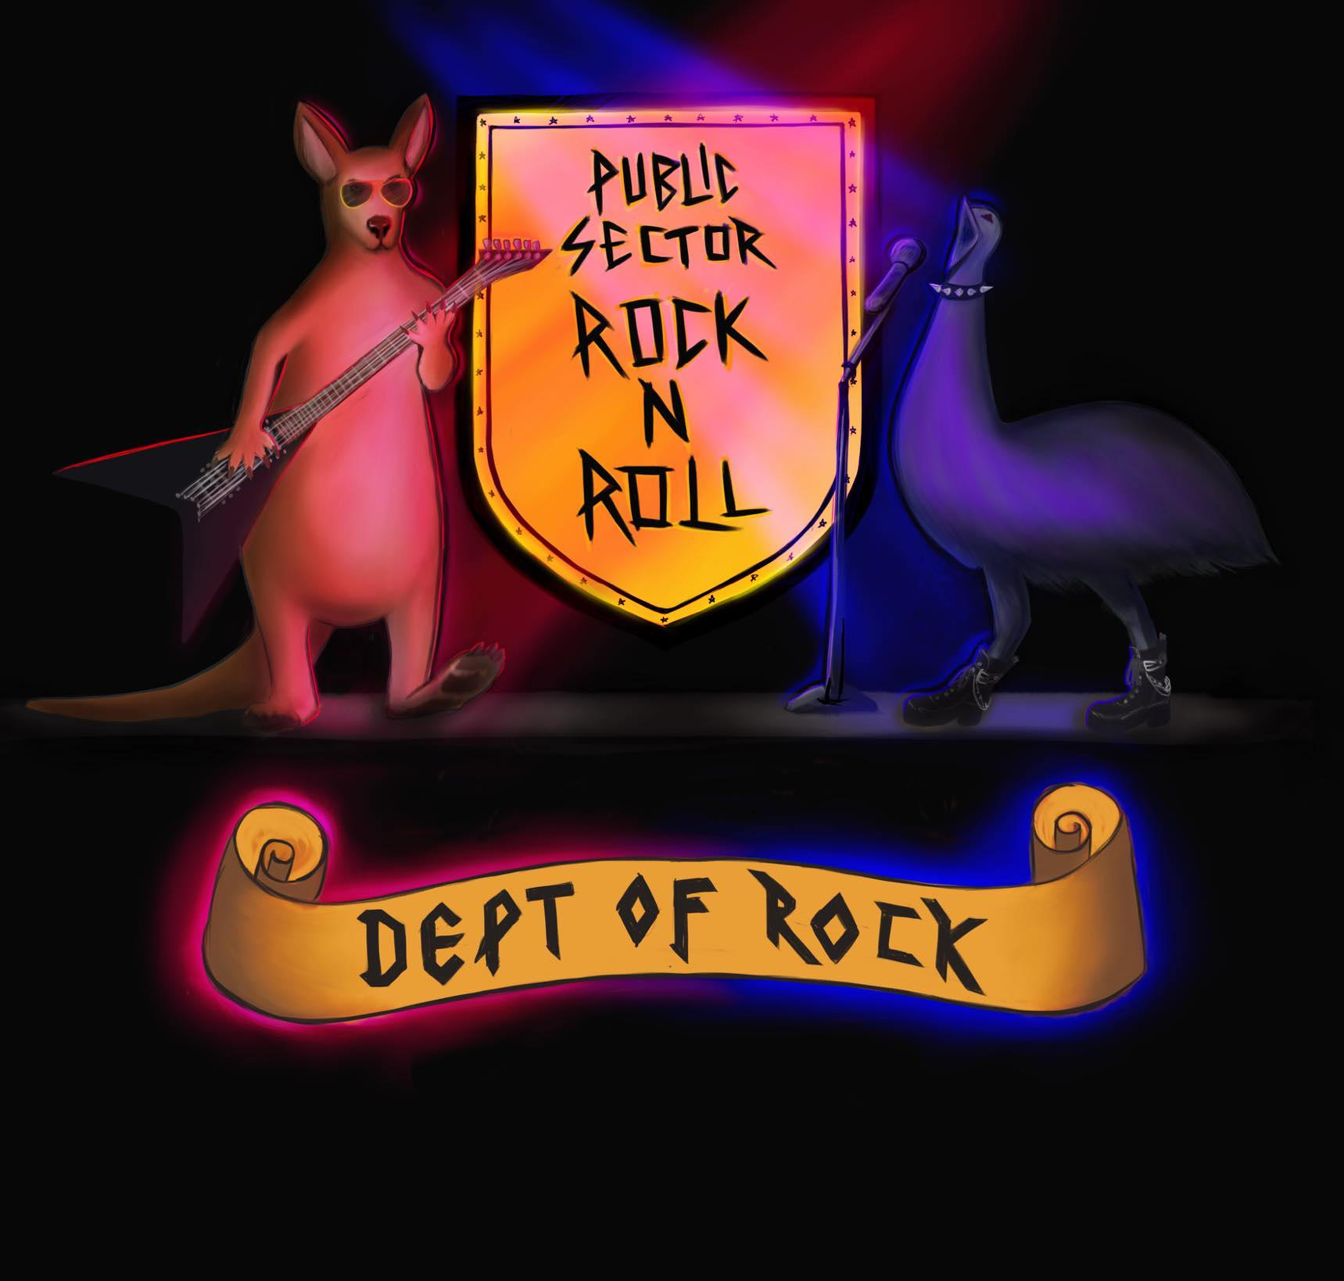
- Registration: 1 August to 20 September 2024
- Heats: Tuesday 1, 8, 15 & 22 October 2024 from 7 to 10:30pm
- Semi-finals: 19 and 26 November 2024 from 7 to 10:30pm
- Final: Sunday 8 December 2024 from 6 to 9pm
Entry Criteria
- Duos and bands can register – no solo artists.
- Fifty percent or more of an ensemble must be ACT or Federal public sector workers. This includes permanent, contract or casual staff in portfolio agencies, departments, institutions and services. Recently exited public sector employees (less than 2 years exited) may be counted.
- Bands can represent a specific government entity or comprise of employees from different jurisdictions and entities.
- All musicians must be amateur. We define as amateur as not being signed with a record label and/or not making a living as a musician.
- Dept of Rock will promote the competition through various channels including social media and press. Entry to the competition assumes musicians consent to having names and images published. Bands are expected to promote the event so we get good crowds.
- Bands play 3 songs or have 15 minutes of stage time in heats and semi-finals. Bands that make it to the finals get up to 20 minutes stage time.
- All musical genres are welcome, and bands can play covers, originals or a mix of both.
- Bands need to be available to play on the dates/times allocated to them in heats, semi-finals and finals.
- Bands that entered the competition in 2023 can enter in 2024 however they must play different songs (except if they make to the finals where a longer set is expected).
- Backline equipment will be provided by Smiths including drum kit, mics/stands, amps, and PA. Bands should use the backline equipment wherever possible to streamline changeovers.
- Racist, sexist, homophobic, transphobic and explicit content will result in immediate disqualification.
- Entry forms are available on deptofrock.com.au and by emailing deptofrock111@gmail.com. Rego opens 1 August and closes 20 September 2024 or until heats are full – there are limited spots.
- Forms should be submitted to deptofrock111@gmail.com. Bands that have been successful in securing a place will receive a confirmation email with the date of their heat.
Judging & Prizes
- Judging panels are made up of volunteers from across the Canberra community and panel make-up will vary across heats, semi-finals and the final.
- Judges assess bands against the following criteria: professionalism, musicality, originality and audience engagement. This gives consistency across events but because panels change there will be variability in judging decisions. The panel’s decision is final.
- Winners of heats, semi-finals and the final are announced at the end of each event. Prizes are awarded at the final.

